**What Is Apache Camel?**

<https://www.youtube.com/watch?v=mCygKfVy88I&list=PLhOKPsimMS-zdKEE_F53TKNROx2uJBPF6>

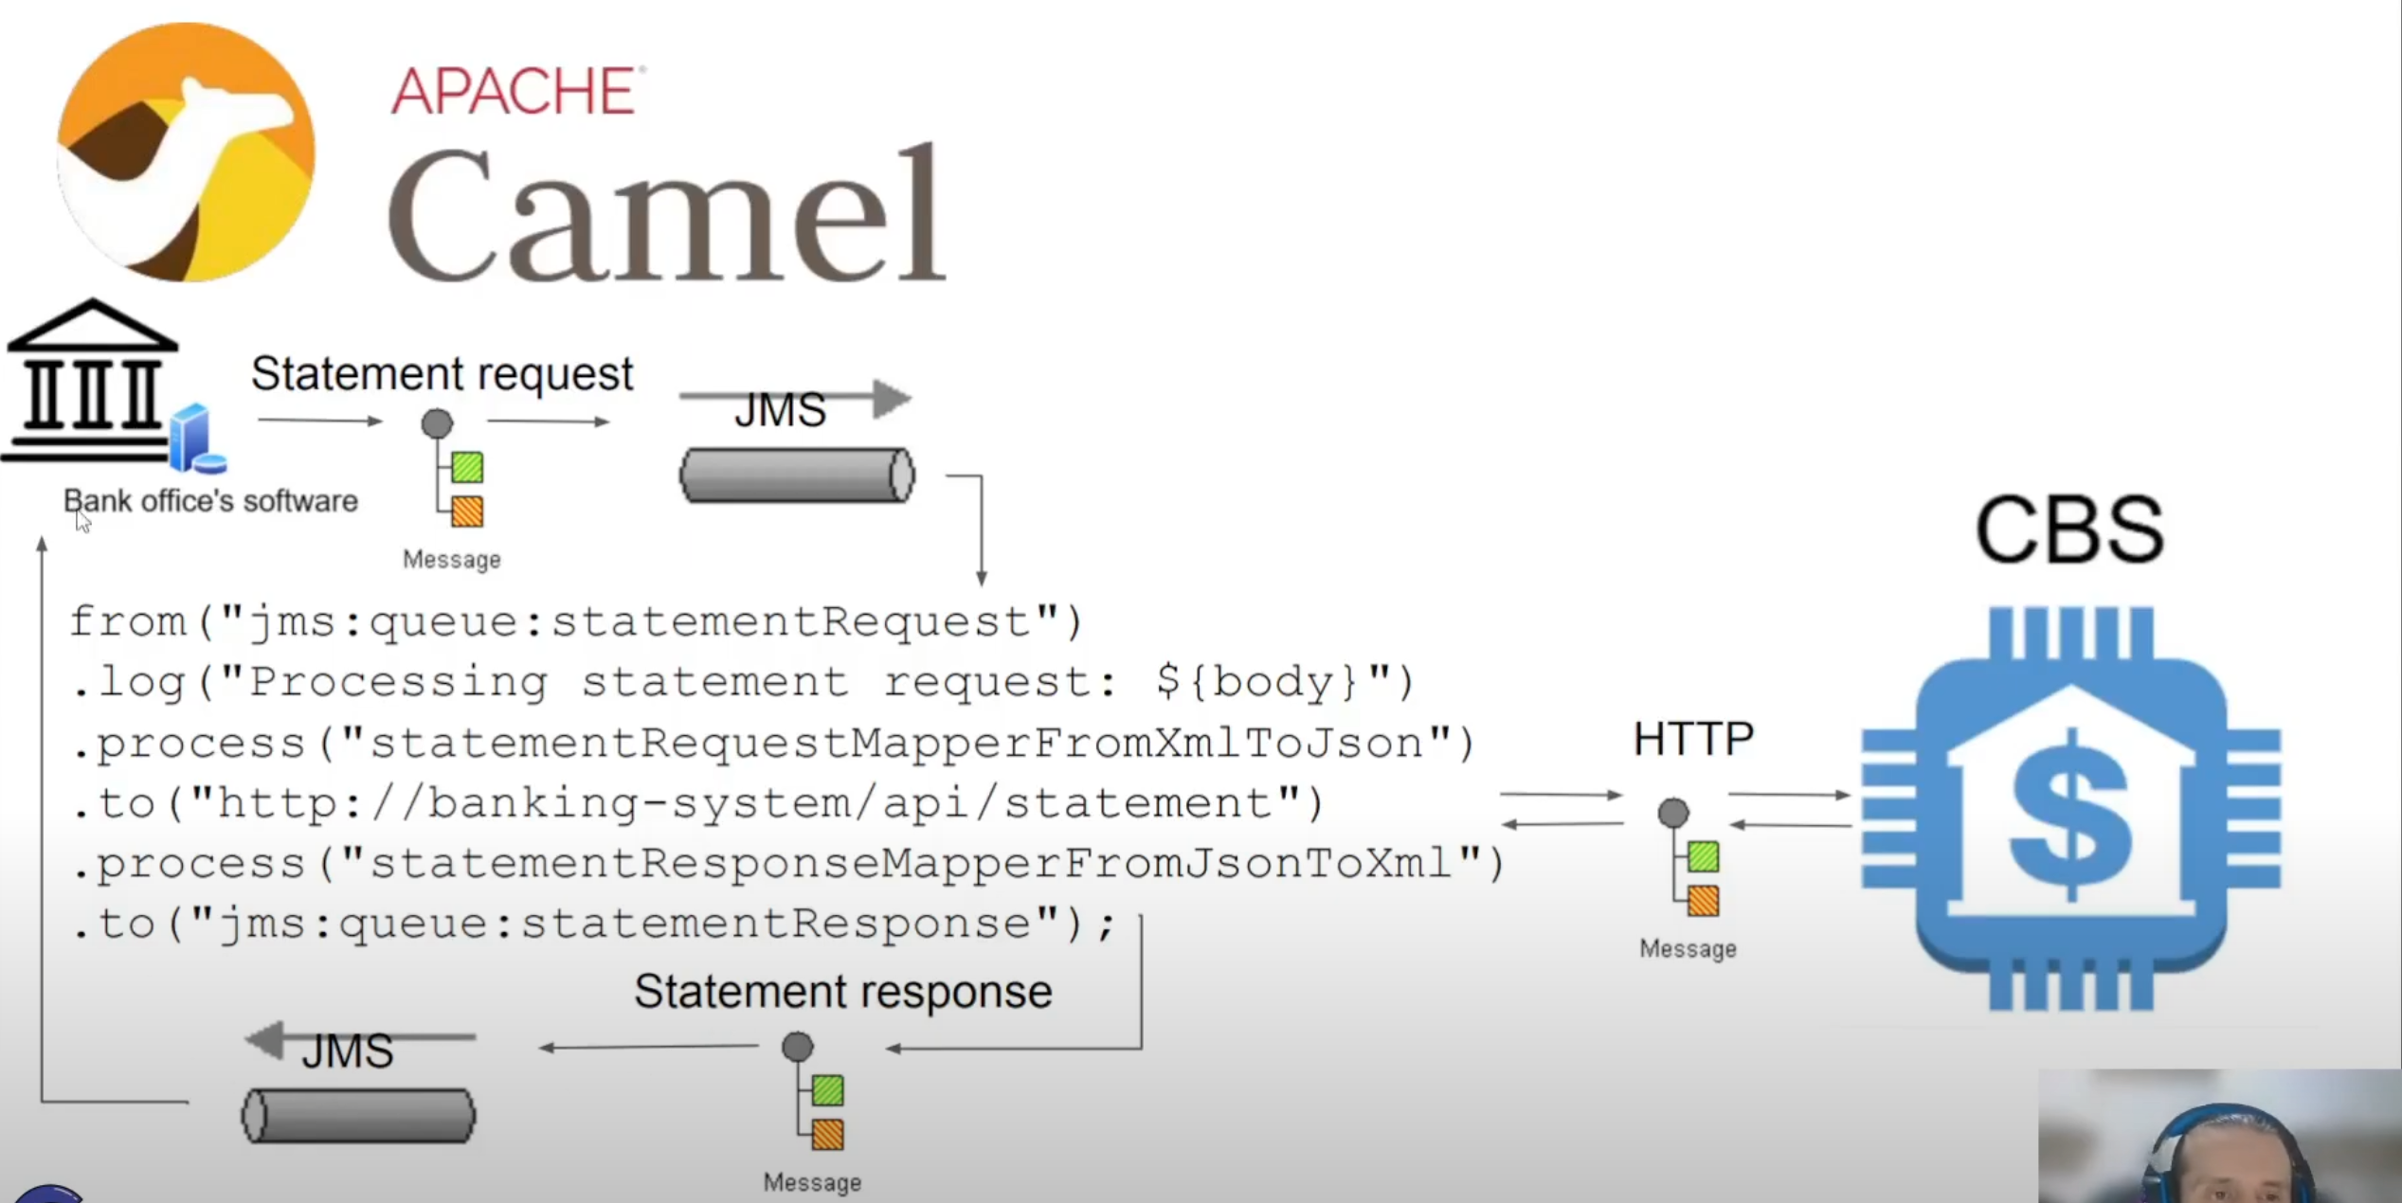

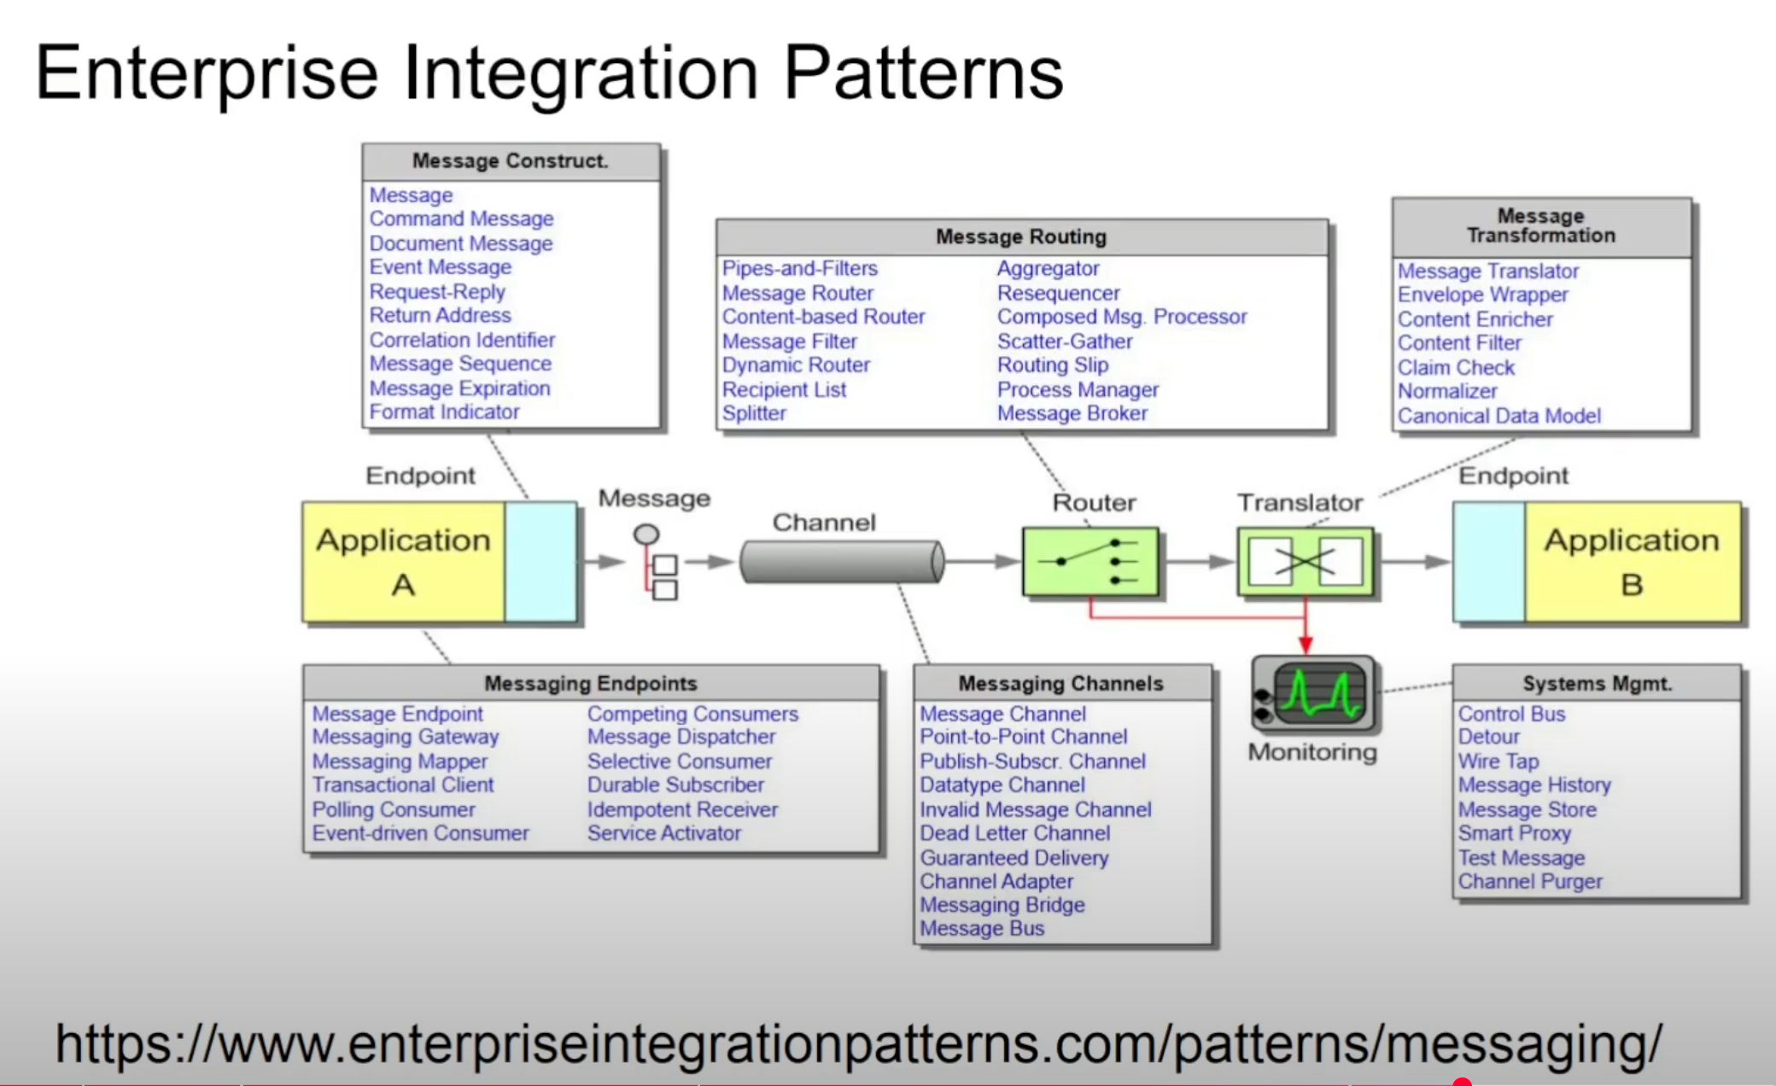

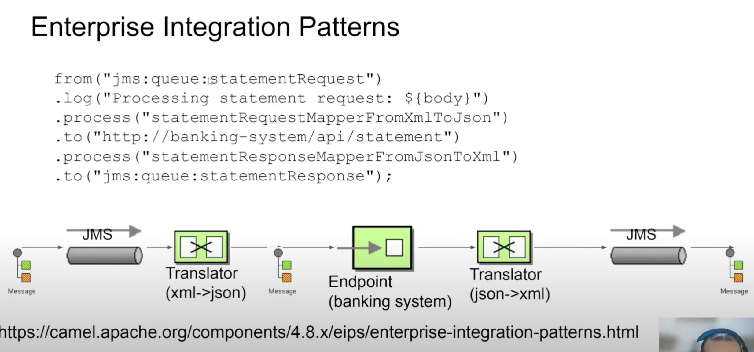

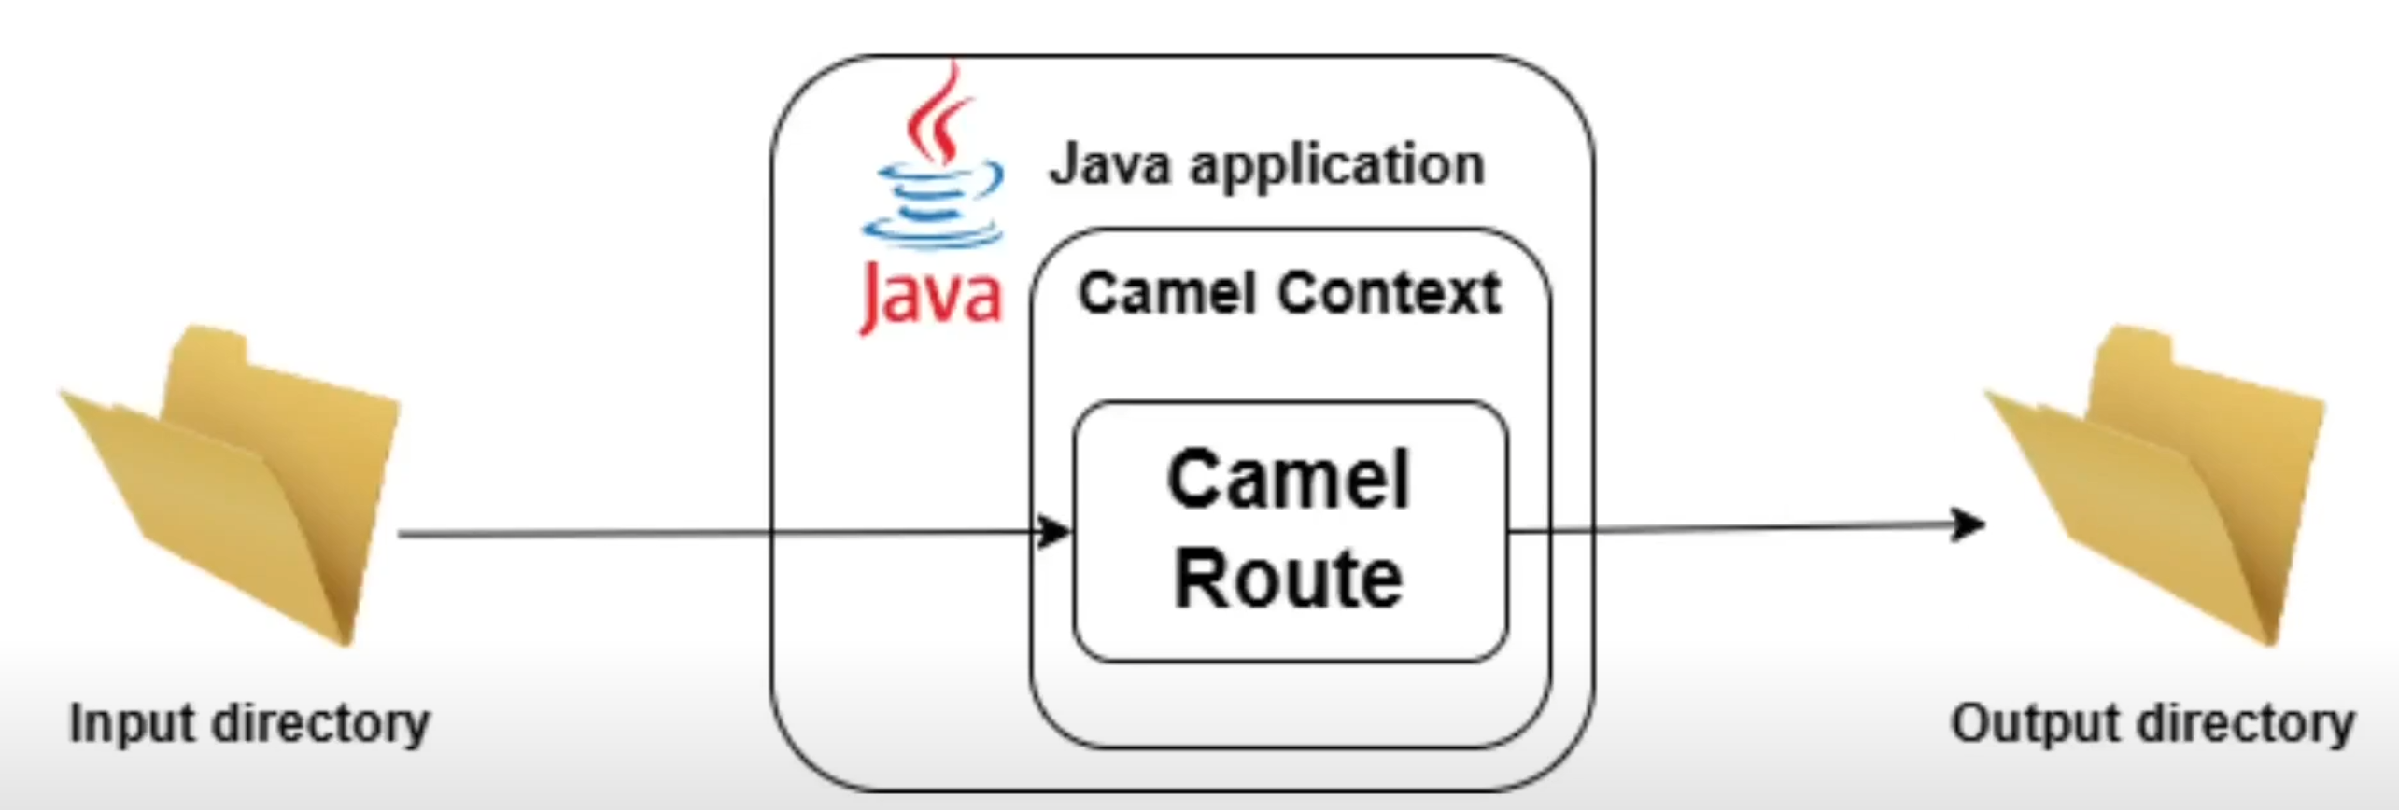

<https://github.com/cyberlogic-consulting/cyberlogic-yt-camel-for-beginners/tree/main/building-your-first-camel-route>

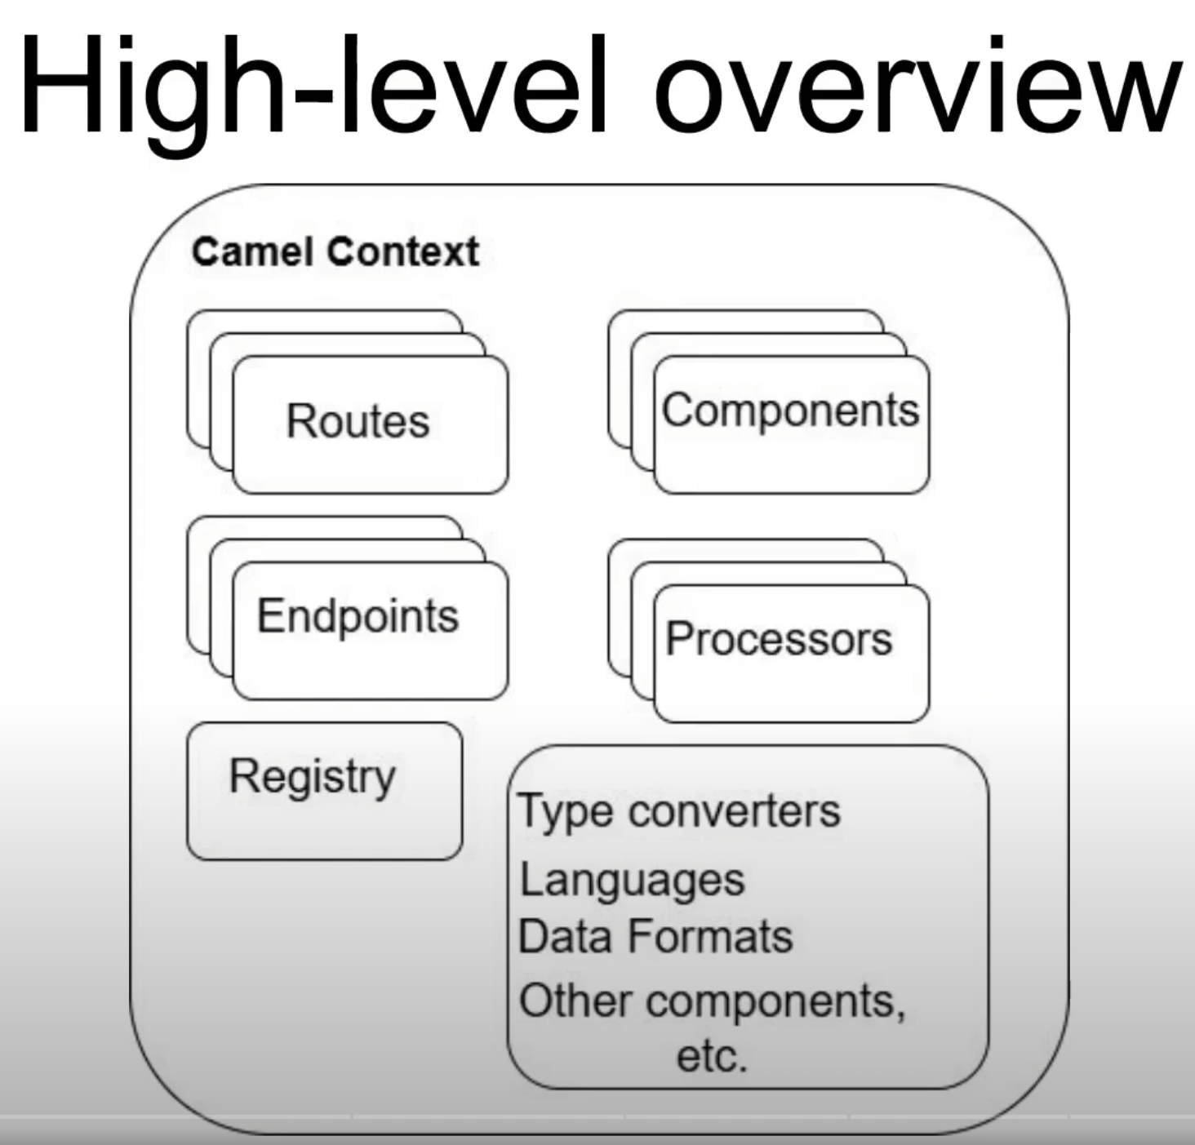

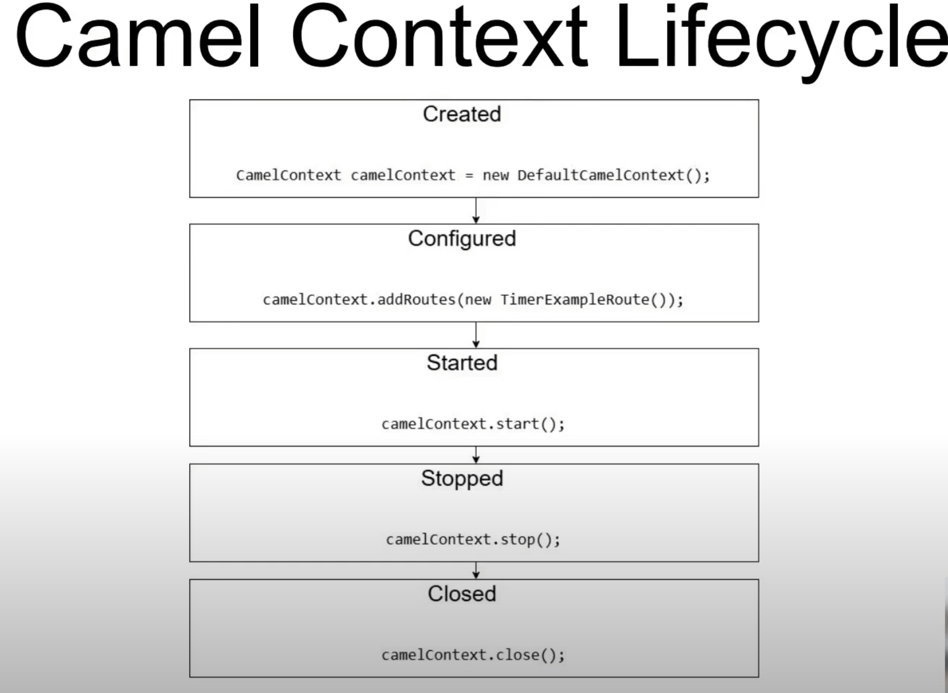

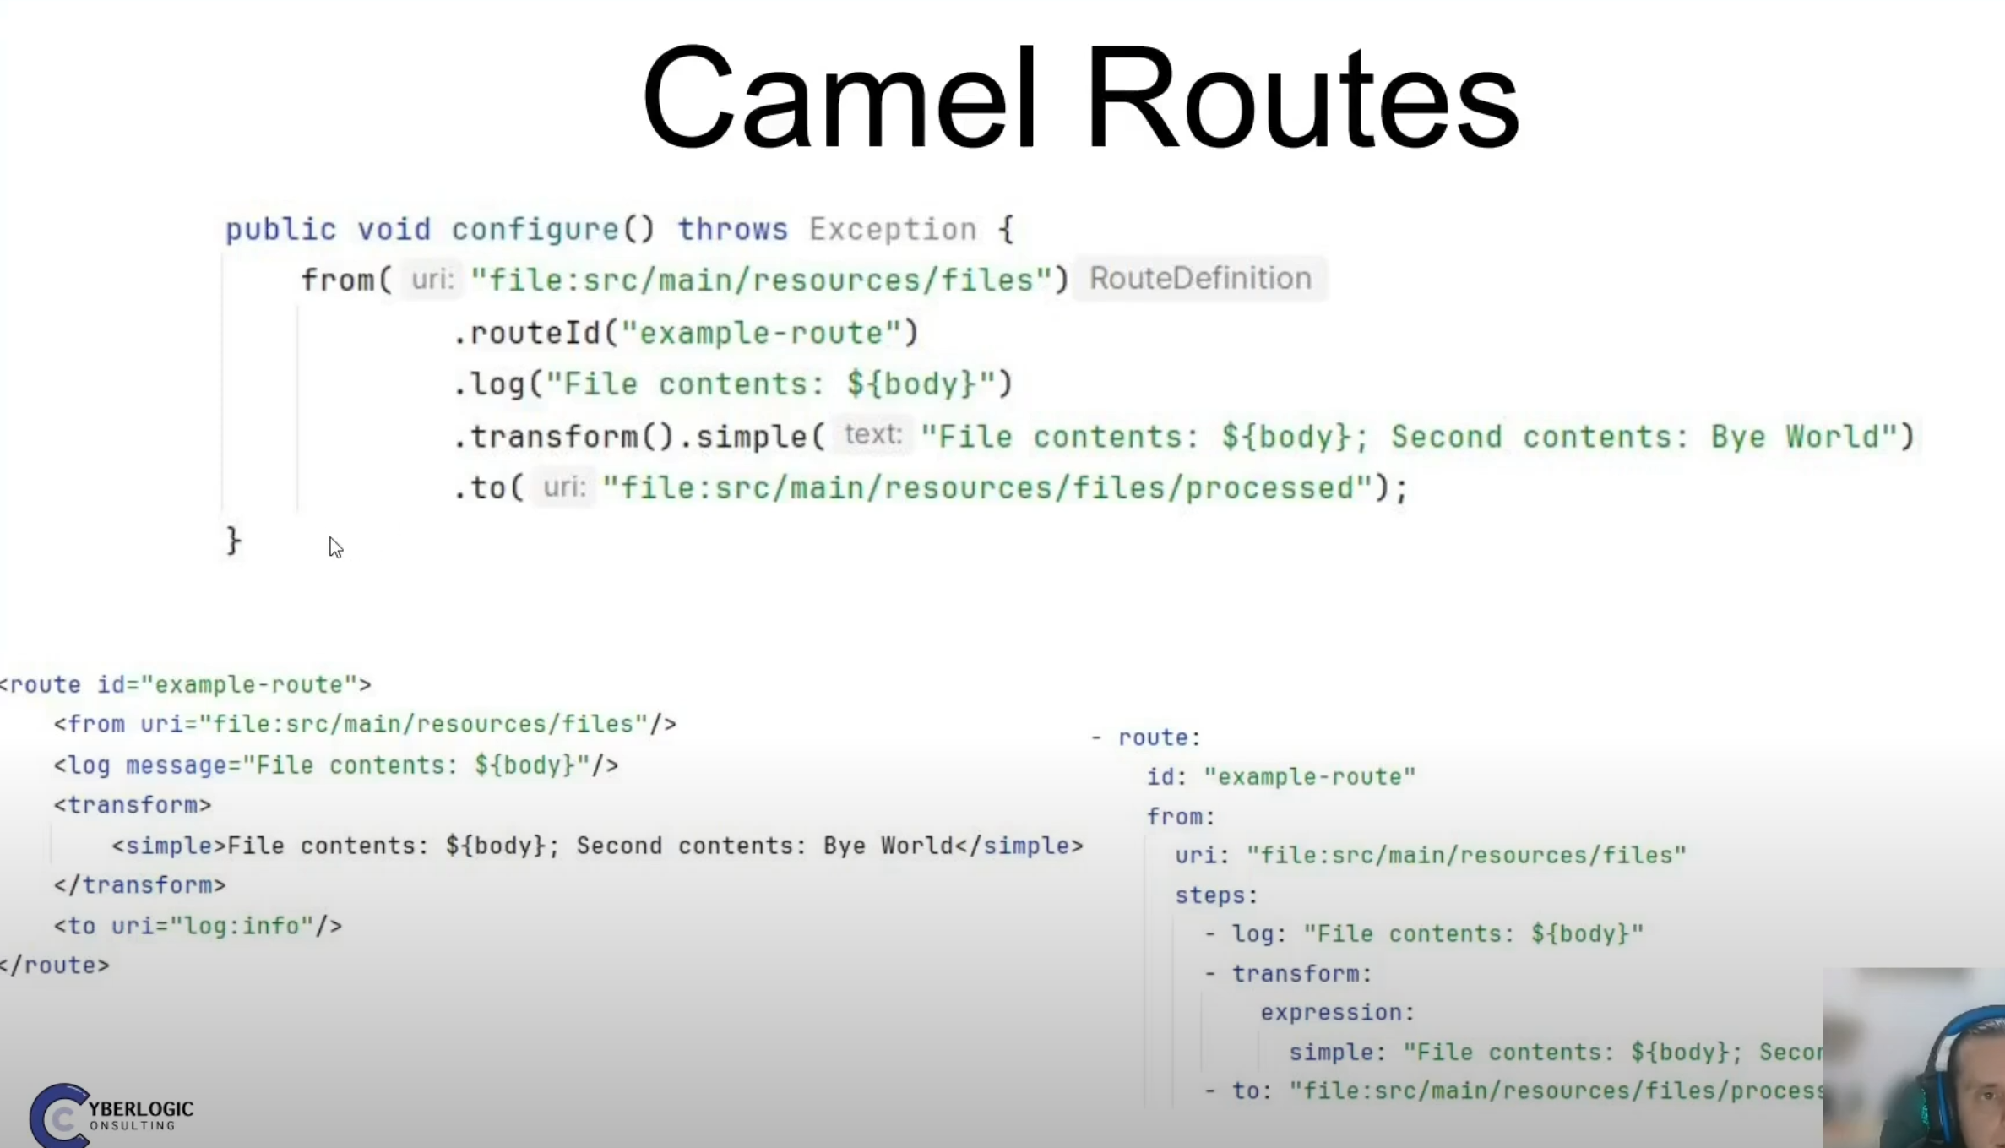

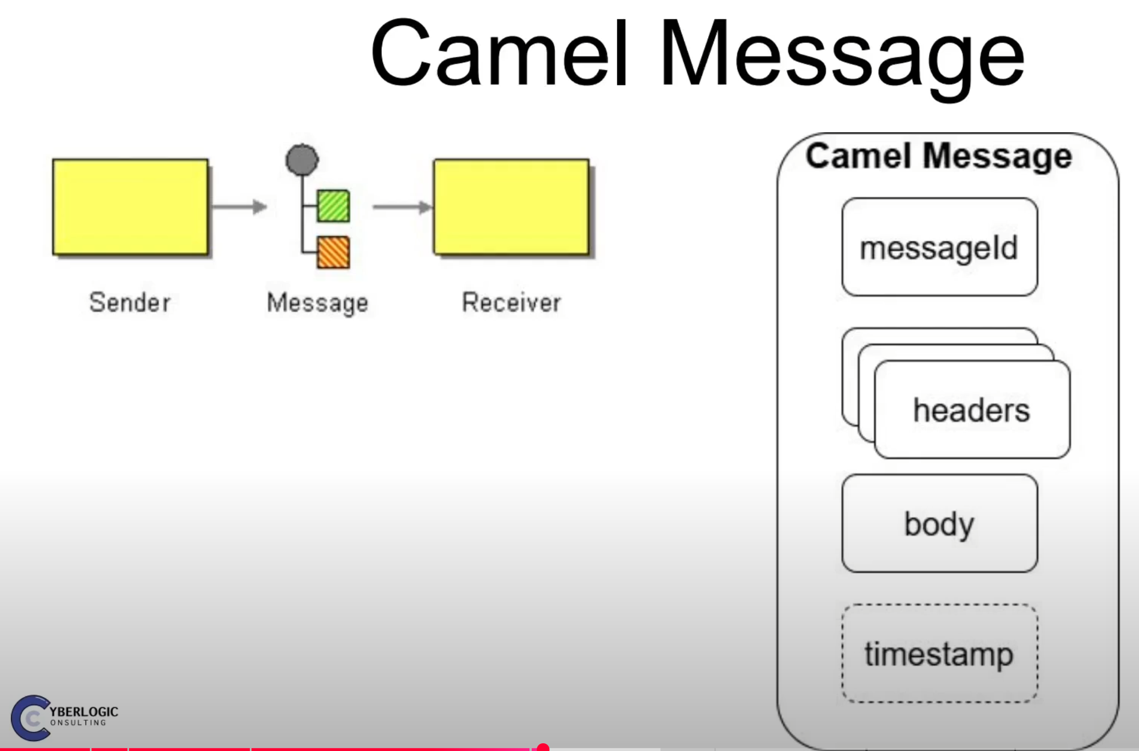

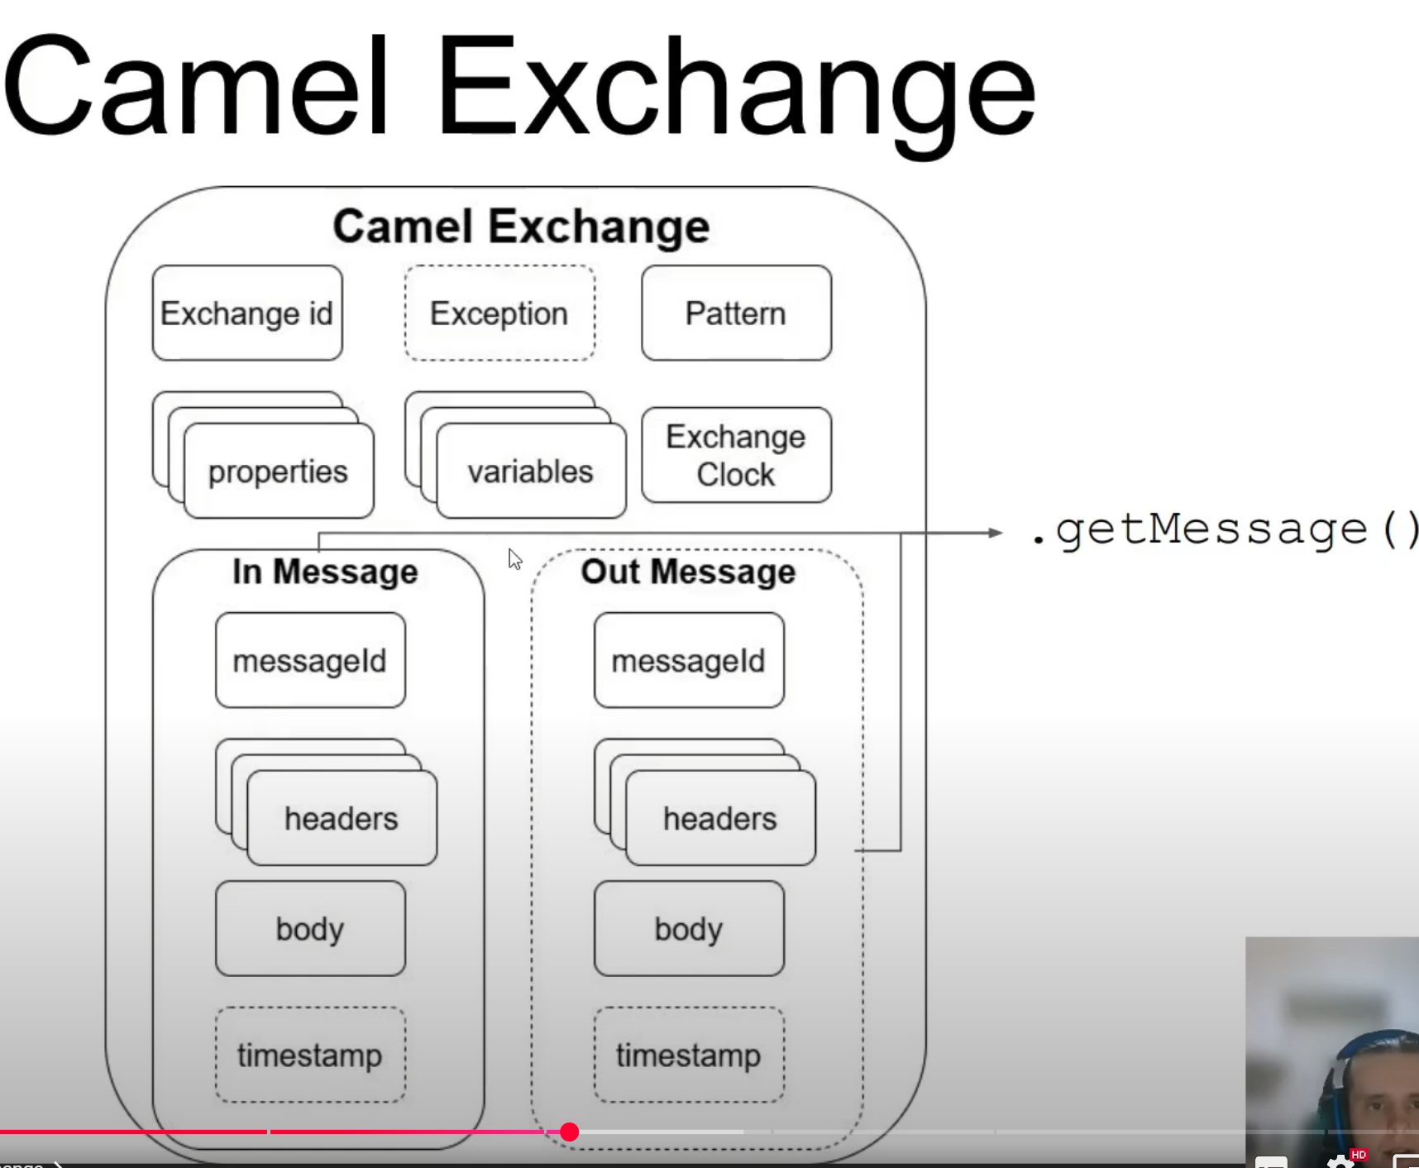

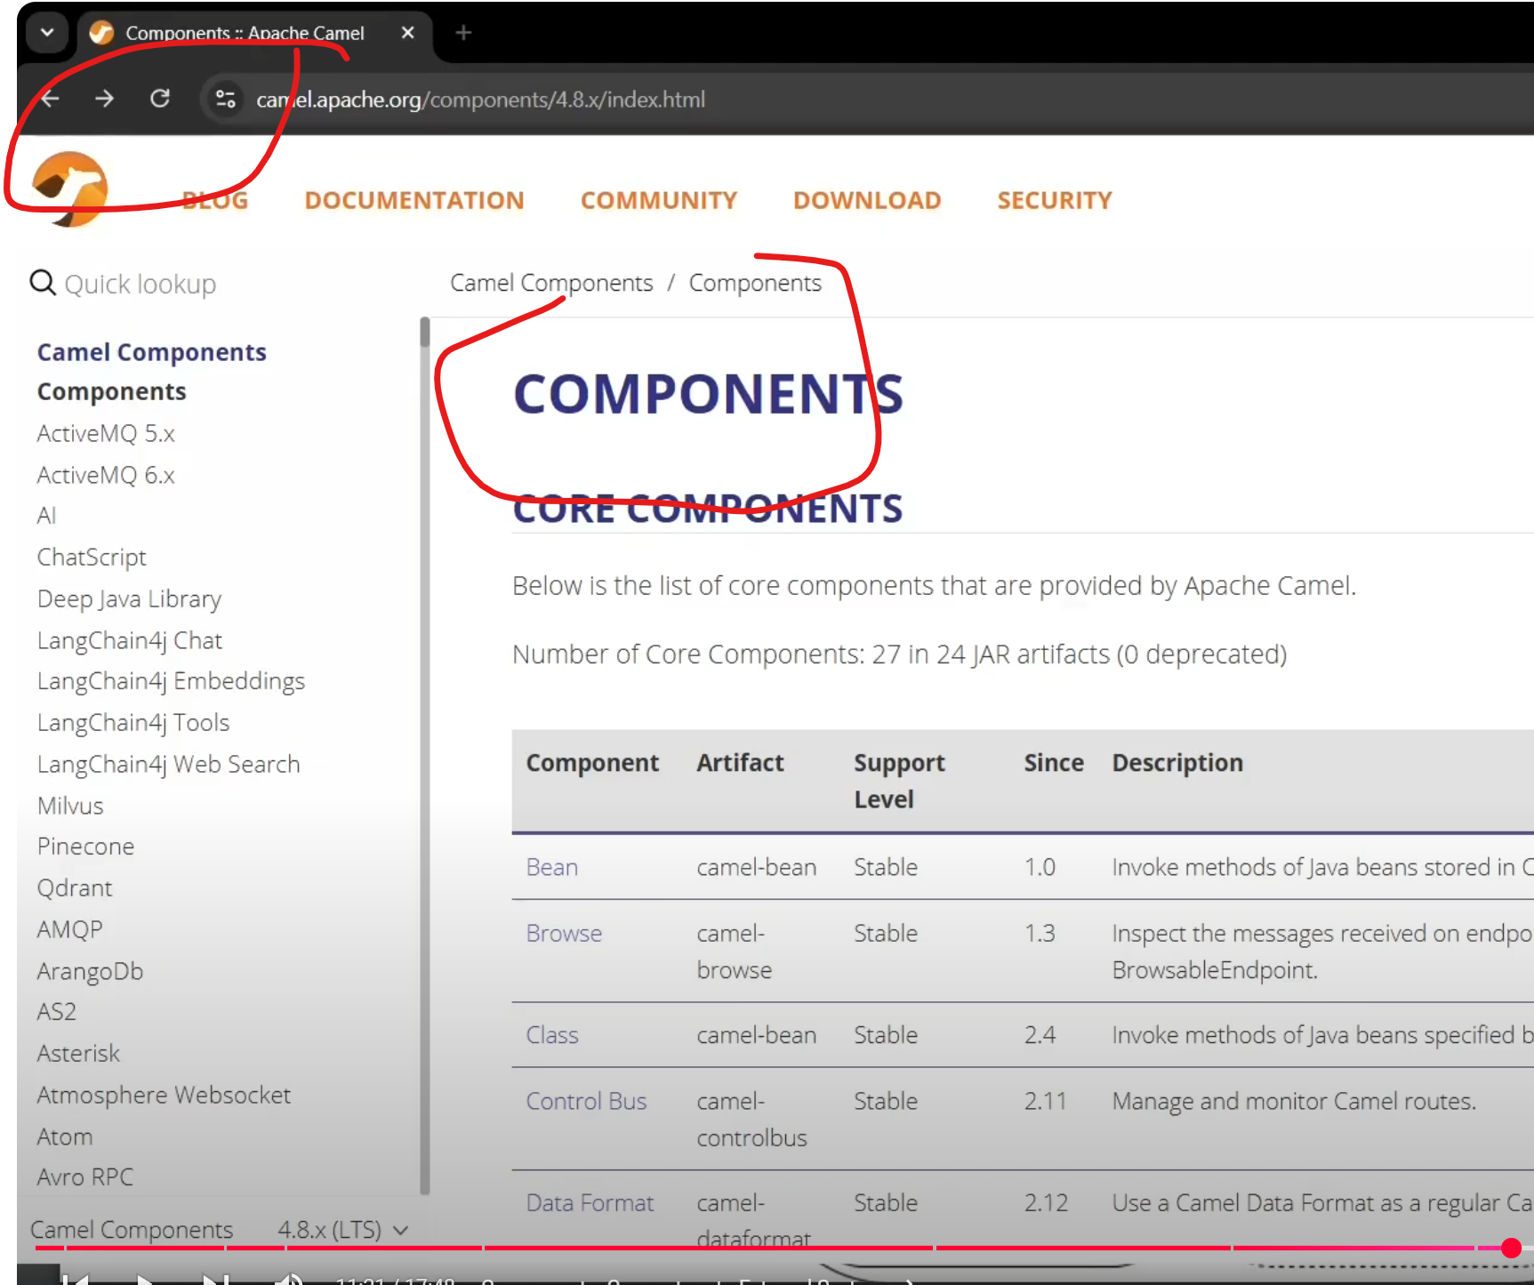

Read properties from external file

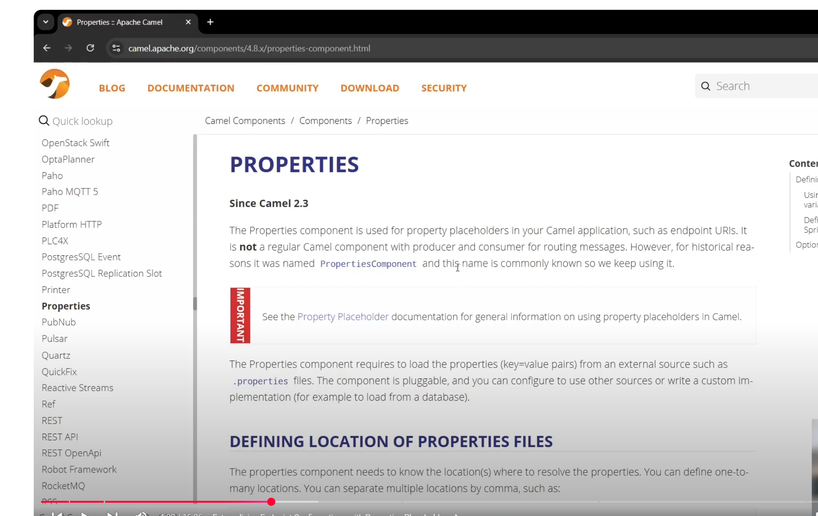

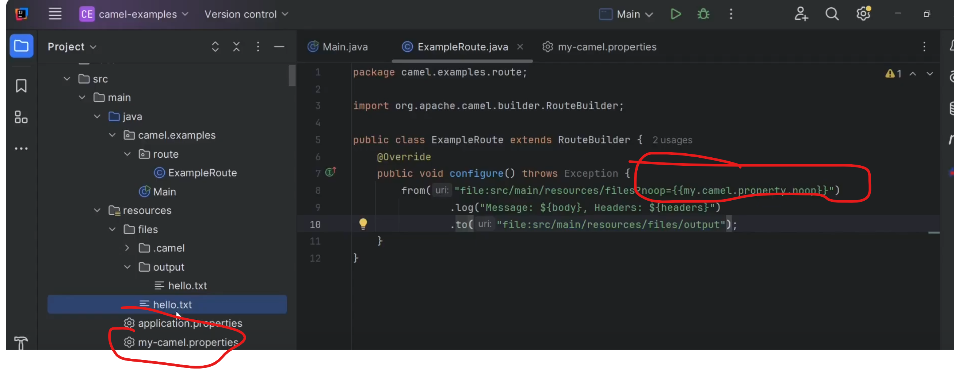

Write the file in different directory based on filecontent   
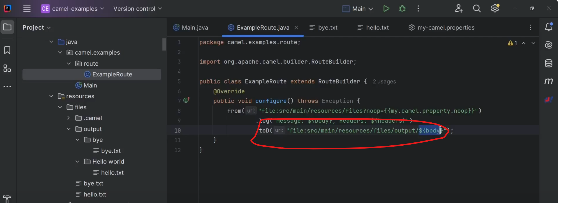

.toD(“file:src/main/resources/files/output/${body}”)

**Apache Camel Routing**

JMS – activemq – connection   
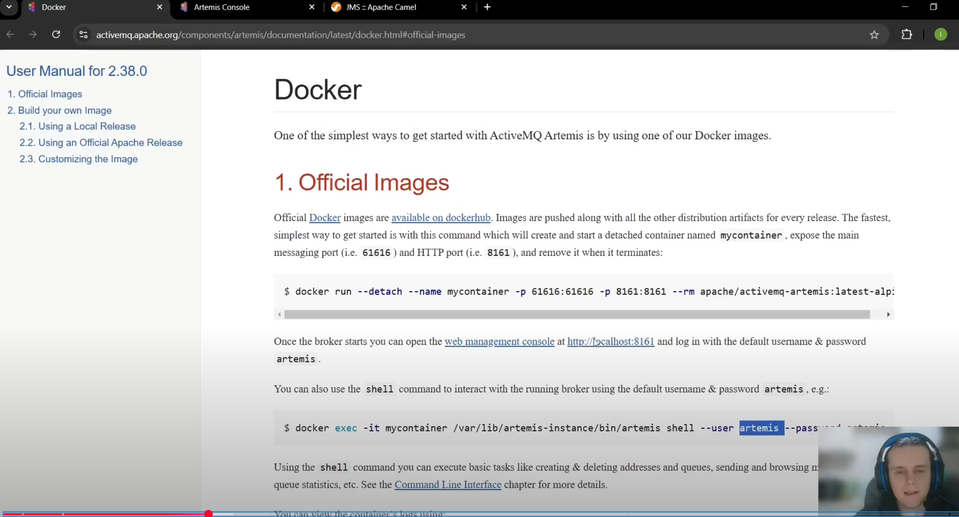

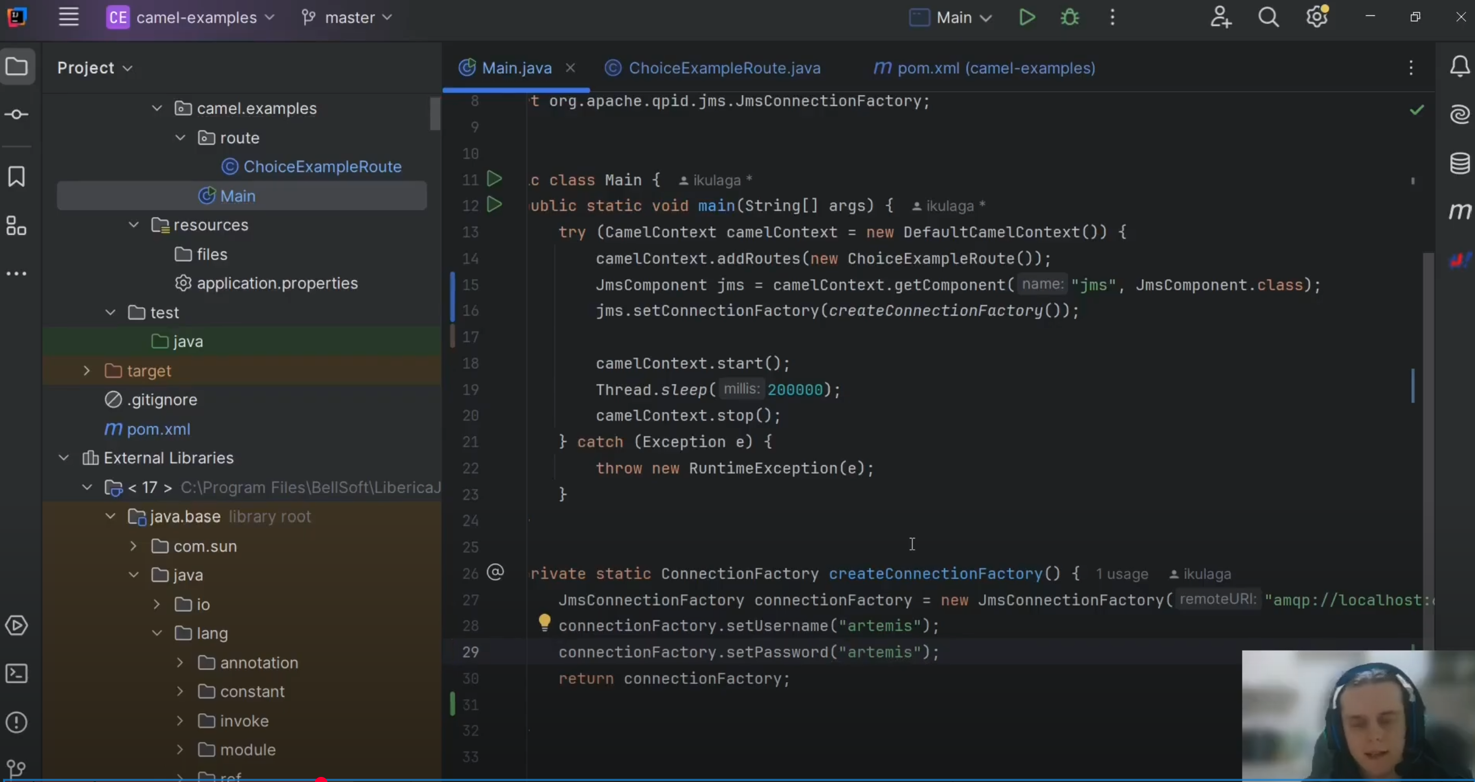

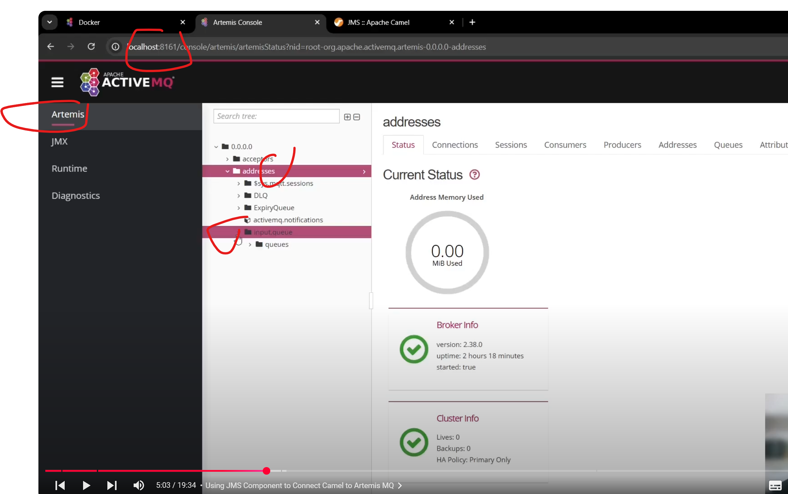

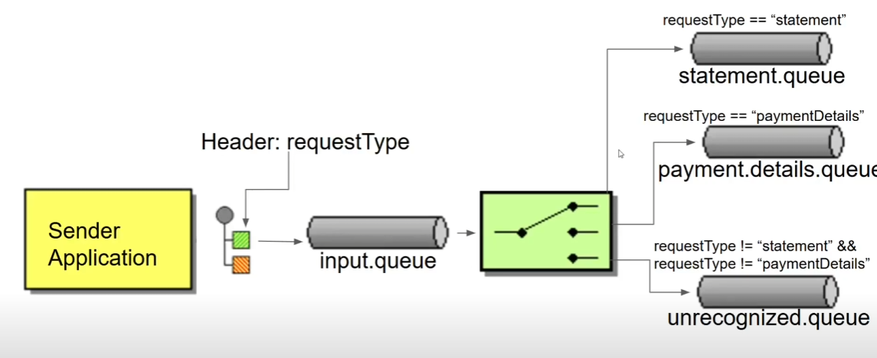

**Routing by header params - Implementing Content-Based Routing with .choice()**  
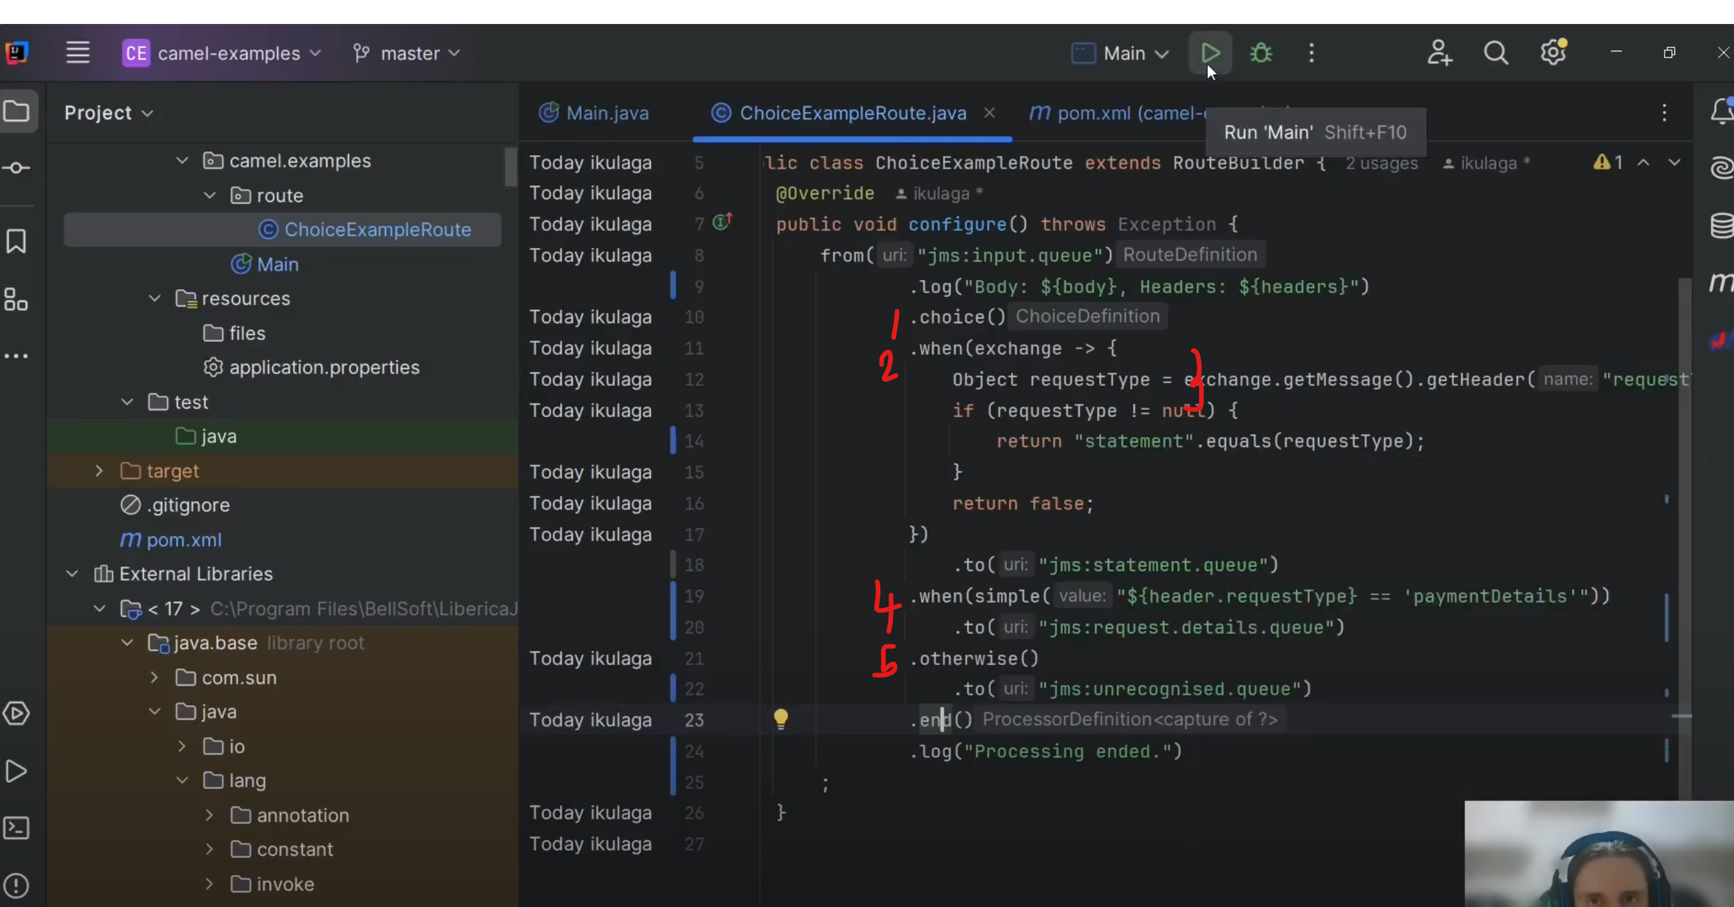

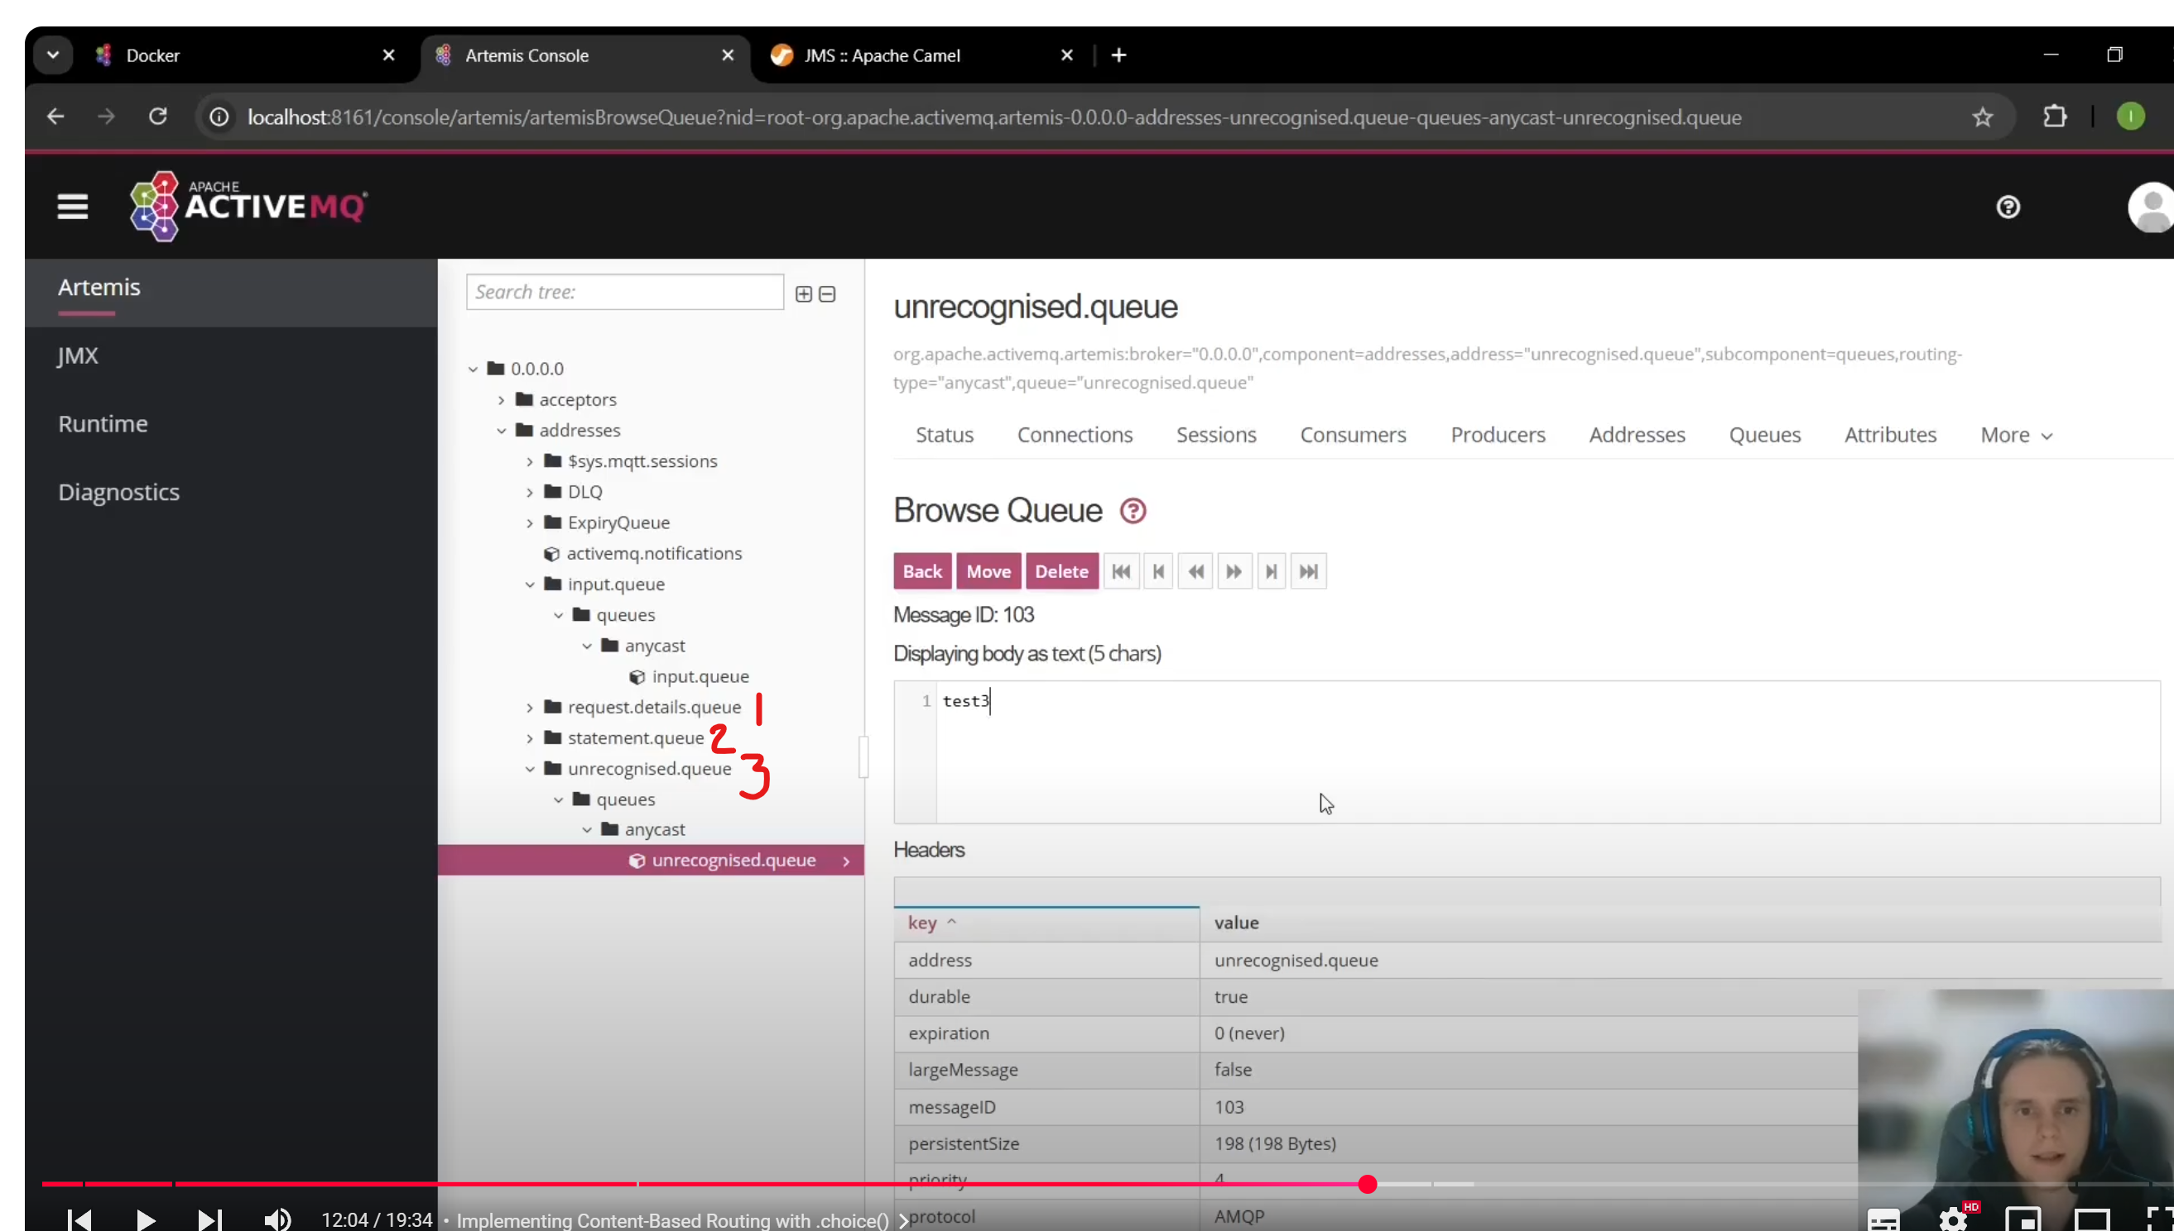

**Using Recipient List for Dynamic Destinations**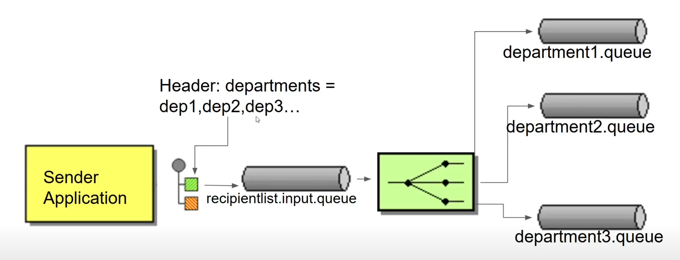

Apache Camel

docker run -p 61616:61616 -p8161:8161 rmohr/activemq

user : admin

password: admin

Activemq admin url - localhost:8161